Exploratory Project

FEEDBACK CONTROL OF INVERTED PENDULUM
Supervised By : Dr. Nilanjan Mallik

Indian Institute Of Technology (B.H.U), Varanasi

Presented By-

Amartya Das - 18134023
Hitanshi Jain - 18135045
Himanshi Barupal - 18135044
Chirag Jangra - 18135029
Sparsh Aggarwal - 18135095

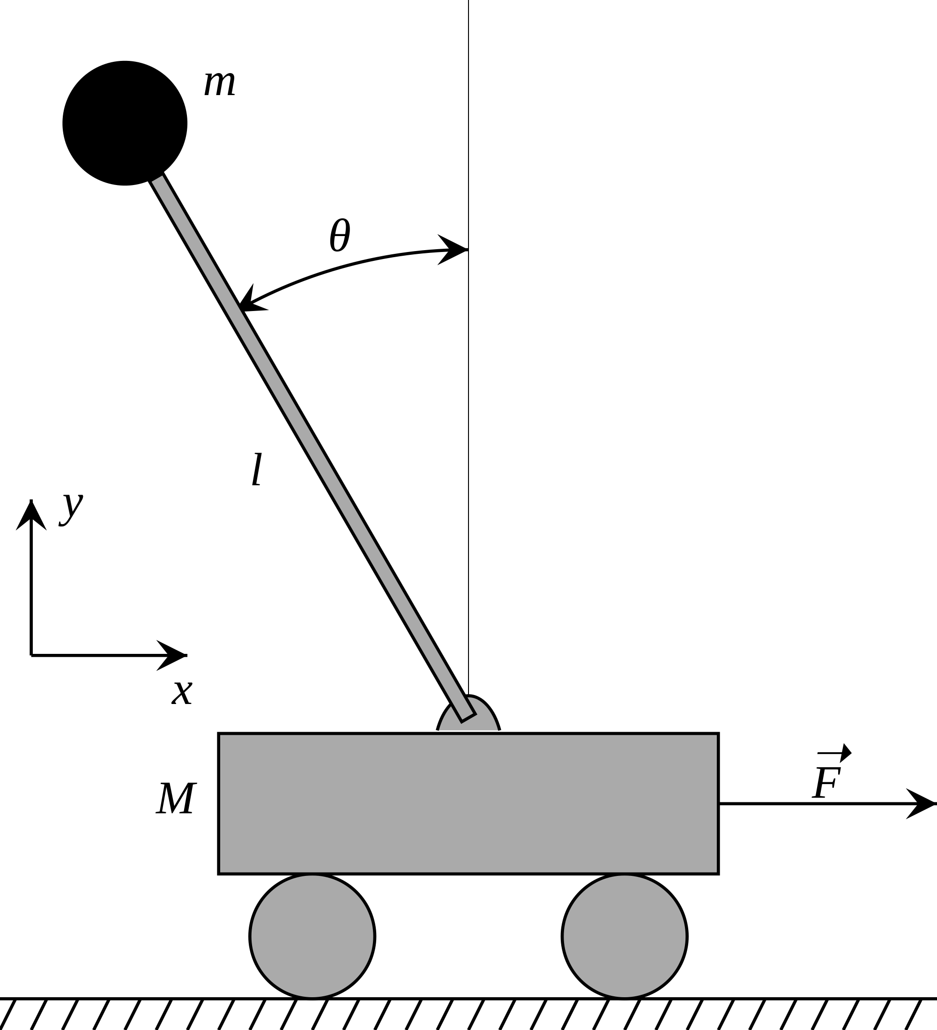

Schematic Diagram of inverted pendulum on cart (fig 1)

ABSTRACT :

The purpose of this project is to study the mathematical principles which govern and affect the stability and instability of a physical system as well as degree of the same.
We study the various methods of stabilizing a system that is inherently unstable from a mathematical standpoint and also perform a simulation to back the results obtained.

LITERATURE OVERVIEW

An inverted pendulum is a pendulum that has its center of mass above its pivot point. It is unstable and without additional help will fall over. It can be suspended stably in this inverted position by using a control system to monitor the angle of the pole and move the pivot point horizontally back under the center of mass when it starts to fall over, keeping it balanced. The inverted pendulum is a classic problem in dynamics and control theory and is used as a benchmark for testing control strategies. It is often implemented with the pivot point mounted on a cart that can move horizontally under control of an electronic servo system; this is called a cart and pole apparatus. Most applications limit the pendulum to 1 degree of freedom by affixing the pole to an axis of rotation.

Whereas a normal pendulum is stable when hanging downwards, an inverted pendulum is inherently unstable, and must be actively balanced in order to remain upright; this can be done either by applying a torque at the pivot point, by moving the pivot point horizontally as part of a feedback system, changing the rate of rotation of a mass mounted on the pendulum on an axis parallel to the pivot axis and thereby generating a net torque on the pendulum, or by oscillating the pivot point vertically.

Our aim is to build an inverted pendulum mounted on a cart that can move horizontally and by using feedback control make it stable and adjust itself to external forces.

METHODOLOGY

Linear Systems And Their Solution

The essence of the project is the control of a linear system. A linear system ( a state space system of ordinary differential equation) can be represented by -
Ẋ = AX + BU -----(1)
Where X is a state space variable (a vector) and BU actually represents the control or the actuator term.
In order to understand the inherent nature of the system in terms of its stability we must ignore the control term for now and analyze the system as -
Ẋ = AX -----(2)
The solution to such a system of ordinary differential equation is given by-
X(t) = eAt X(0) -----(3)
where X(0) is the innitial condition of the system.

Now, an alternate and easier to calculate solution is -
X(t) = (TeDtT-1)X(0) -----(3)
where D is the diagonal matrix of the eigenvalues of A and T is the matrix having eigenvectors of A as its column.

Stability And Eigenvalues

Let λ be an eigenvalue of the A matrix. Then λ can be written as-
λ = a + ib
As D is the diagonal matrix of eigenvalues of A, eDt will be a diagonal matrix with the ith diagonal element being eλt.
Now from Euler’s expansion,
eλt = eat[cos(bt) + isin(bt)]------(4)
The term within the bracket always oscillates between 0 and 1. Hence it is the term eat that decides whether the system is growing with time or decaying with time.
Hence, we can infer that-
If all the eigenvalues of the matrix A are negative, the system represented by eq(2) is inherently stable.

The system we have been discussing until now is continuous time system, where we monitor the system at all intervals of time. Another common approach is to monitor the system at regular intervals of time. It is then known as discrete time system and can be represented as-
Xk+1 = Ãxk -----(5)
where Ã = eAΔt
Let λ be an eigenvalue of the matrix Ã. Then λ can be represented as-
λ = Reiθ
The system will be stable iff R<1 for all eigenvalues of Ã.

Linearization About A Fixed Point

Our system of study, namely the inverted pendulum, is a non linear system. Hence, in order to apply our linear analysis to the system we have to make a linear approximation of the system.
A non linear system may be defined as-
Ẋ= F(X)-----(6)
where f is a non linear function.
Before proceeding we need to define fixed point. A fixed point of a non linear system (Xf) is defined as-
Xf֗֗• = F(Xf) = 0 -----(7)
Linearisation of a non linear system is based on the intuition that if we focus really close on the fixed point, the non linear system appears to be linear.
Linearisation is performed as follows:
1) First we find the fixed point of the system
2) Next we calculate the Jacobian of F wrt X, J = (DF/DX) -----(8)
3) Now we calculate the Taylor Series Expansion of F(X) about Xf we have-
Ẋ = F(X) = F(Xf) + J.(X-Xf) + J2.(X-X)2 + (Higher order differential terms) -----(9)

From the definition of fixed point, F(Xf) = 0
Ignoring the terms from quadratic term onwards, we have-
Ẋ = (DF/DX)X -----(10)
which is a linear system, and the eigenvalues of (DF/DX) define the stability of the system.
Hardman Groveman Theorem : If all the of J have a non zero real part, then the linearisation describes the neighbourhood well.
A good control system helps keep the system in the linearisation region.

Case Study : The Pendulum

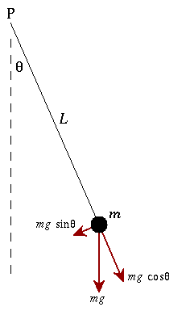
The equation governing the state of the bob is-
Ӫ = (-g/L) sin(θ) -δθ•-----(11)
For simplicity in analysis we consider
(-g/L) to be unity.
We define our state space vector X as
X== -----(12)

There can be 2 fixed points of the system (0,0) corresponding to pendulum in the bottom position and (π,0) corresponding to the upward position.
Let us consider the damping term δ to be 0.1
In the pendulum downwards case -
The Jacobian comes out to be:
Jdown=
having the eigenvalues -0.05+0.9987i and -0.05+0.9987i
As both the eigenvalues have a negative real value part, the pendulum downwards system is inherently a stable system.
In the pendulum upwards case -
The Jacobian comes out to be:
Jup=
having eigenvalues -1.0512 and 0.9512
This system has an eigenvalue with positive real part, hence the pendulum up is inherently unstable system.

Controllability
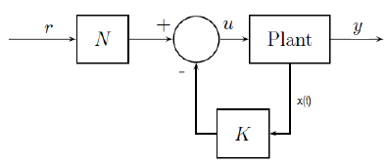

We return to our first equation Ẋ = AX + BU
Full State Feedback Control : We measure the state of our system (X) and if we find the system moving towards instability, we force it to stability using the input U. (In the case of inverted pendulum, the applied force is the input.)
U is a function of the state X which is very obvious. Although there can be many functions relating U to X, the linear function U = -KX -----(11) proves to be the most effective for a linear system.
Plugging in equation 11 in equation 1 we get
Ẋ = (A-BK)X-----(12)
By choosing an appropriate K, we can drive the eigenvalues to stability.
The Controllability of a system depends upon the values of A and B. The controllability matrix C is defines as-
C = [B (AB) (A2B) (A3B).......(An-1B)] ------(13)
The system is controllable iff C is a full rank matrix, i.e its rank is same as the number of elements in the state space vector X.

It is worth noting that sometimes, a non linear system may become unstable after linear approximation. However, if we include some of the truncated non linear terms, the system becomes controllable.

Controllability, Reachability And Eigenvalue Placements

The following are equivalent statements for a linear or linearly approximated system:
1) The system is controllable.
2) Arbitrary eigenvalue placements is possible
This means we can have a desired set of eigenvalues that would define how stable our system is. Now, if our system is controllable, we can find a K such that the matrix (A-BK) will have those set of eigenvalues.
However this will not be possible if we want more repeated eigenvalues than there are columns in the matrix B.
3)Reachability
If the system is controllable, we can find a U to steer the state of our system to any state X in the state space vector space.
This can be proved using Cayley-Hamilton Theorem.

Degrees of Controllability and Gramian

The rank of the controllability matrix C tells us whether or not a system is controllable. However, the system is more controllable along certain directions in the state space than the others, about which C does not give an insight. We calculate the Gramian (W) for that purpose.
Solution of X for equation Ẋ = AX + BU is given by-
X(t) = eAt X(0) + 0∫t eA(t-Г) BU(Г) dГ -----(14)
where Г is the time when the input U is applied.
The Grammian W is defined as-
W=0∫t (eɑBBTeά)dГ -----(15)
where ɑ = AГ and ά = ATГ
Because W is real valued and symmetric, it will have positive real eigenvalues.
As all the eigenvalues are non negative, they can be arranged from the largest to the smallest.
The eigenvectors corresponding to the largest eigenvalues are the most controllable directions in state space.

Stabilizability :
A system is stabilizable iff all of its unstable directions are controllable.

All in all we can say,
Ẋ = AX + BU is stabilizable iff all unstable and lightly damped eigenvectors of A are in the controllable subsace.
That is the controllability matrix C must touch all the dimensions having the unstable eigenvectors.

Linear Control Regulator

Overall, our aim now is to find an appropriate k such that the eigenvalues of the matrix (A-BK) becomes negative.
Often times the Eigenvalues we set arbitrarily might not work fine (even if they are negative) and some tuning can usually lead to things to work.

However, there is a mathematically sound way of computing the desired eigenvalues that are optimal in some sense, known as Linear Control Regulator or (LQR).

We need to give as input the covariance matrices Q and R. Q controls how fast you want to converge and R controls the control expense. For example, if our motors are not very strong we may want to penalize aggressive motions, this can be achieved by setting R to be higher.
Taking Q and R as input LQR gives out the optimally desired eigenvalues we must use for stabilization. The effect of using LQR is a better-stabilized system than manually choosing eigenvalues.

Simulation

Next we apply the mathematical theories on our system, and develop a simulation to control the system in Python using matplotlib.

The simulation link can be found at the following link.
https://colab.research.google.com/drive/1SXrTkMyG2f9d4xWhVF-IxTs8EEFp0IeU?usp=sharing

After opening, run the cells in order to see the simulation

RESULTS AND DISCUSSIONS

After running the simulation we observe that upon implementing a proper control function the resulting state space system described by the equation Ẋ = (A-BK)X is fully stable at any instant of time we observe.
There are several applications of feedback control in general and self balancing robot in particular.
Feedback control is being used in numerous technologies daily, like space satellites and aircraft navigation. It can be used to build self driving cars as well as increase safety automobiles of today by increasing their stability.
Inverted pendulum on the other hand is the driving principle behind self balancing robots. These is whole new domain in itself and have numerous applications like humanoid robots and mars rovers.

CONCLUSION

Scope for improvements -

In this case we apply the control term BU, where U=-KX. Hence, we assume that we have access to all the variables defining the state X.
However this may not always be the case. In that case we need to find a way of estimatng the full state of the system from a few variables defining X.

We can use other methods to control the system. Predictive control techniques can be
applied, which aim at determining a series of future control actions that will
balance the system. Adaptive control techniques can also be used. Such
methods are useful when certain parameters of the system change during its
simulation.

REFERENCES

1) https://www.youtube.com/playlist?list=PLMrJAkhIeNNR20Mz-VpzgfQs5zrYi085m

2) Data Driven Science and Engineering by Steven L Brunton

3) https://www.mathsisfun.com/algebra/eigenvalue.html

